All proceeds go to assist Jack Plowman during his current medical treatments.

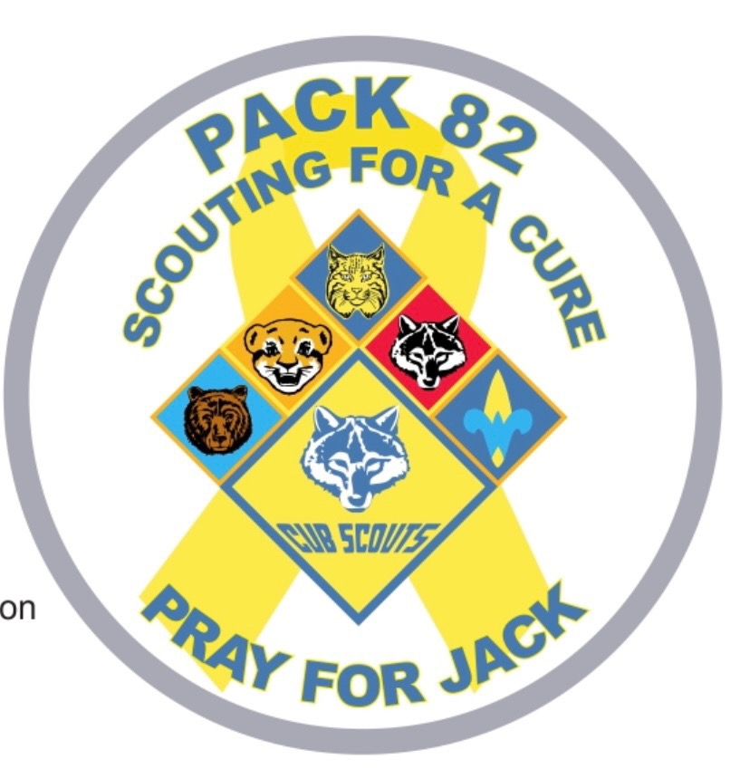

Name_______________________________________Phone:____________________
Mailing Address_________________________________________________________
Email Address:__________________________________________________________

Silver Border $10 X Quantity ______= _________
Yellow Border $15 X Quantity. ______= _________

Total Submitted: _____________

If you have any questions, please contact Harry Labhart (334-606-3886 or hlabhart@yahoo.com) or any member of Pack 82 or Troop 17. Thank you for your support.

Please send this form and payment (payable to Cub Scout Pack 82) to the following address:
Harry Labhart
202 Coyote Lane
Gordo, AL 35466

